4

REPORT FOR: | TRAFFIC & ROAD SAFETY ADVISORY PANEL
Date of Meeting: | 31October 2018
Subject: | INFORMATION REPORT  Wealdstone Liveable Neighbourhood Bid
Key Decision: | No
Responsible Officer: | Paul Walker, Corporate Director - Community
Portfolio Holder: | Councillor Varsha Parmar - Portfolio Holder for Environment
Exempt: | No
Decision subject to Call-in: | No, report is for information
Wards affected: | All
Enclosures: | Appendix A – travel gateways and connections  Appendix B – Sub-neighbourhoods

Section 1 – Summary and Recommendations

This report sets out progress being made with developing a Liveable Neighbourhood Bid for Wealdstone.

Recommendations:

None, the report is for information only.

Reason: (For recommendations)

None, the report is for information only.

Section 2 – Report

Introductory paragraph

- During 2017 a new Mayor’s Transport Strategy was approved. The key objective of the strategy was to increase the proportion of travel by sustainable transport modes to 80% by walking, cycling and public transport and reducing 3 million car journeys each day by 2041. The aims of the strategy are:

- Healthy Streets and healthy people
- A good public transport experience
- New homes and jobs

- The healthy streets for London initiative aims to ensure people and their health are put at the centre of decision making in London. It ultimately aims to reduce reliance on personal vehicles, in favour of walking, cycling and using public transport to create a healthy city. The Liveable Neighbourhood programme will be an important delivery mechanism for healthy streets.

- In the summer 2017 the Liveable Neighbourhoods Programme Guidance was issued in line with the key policy drivers in the Mayors Transport Strategy.

- Harrow intends to submit a bid for Wealdstone this year and the deadline for bids is November 2018.

Options considered

- The Liveable Neighbourhood programme is open to London Boroughs annually and provides an opportunity to submit bids for projects that deliver healthy streets. Bids up to £10 million can be submitted under this programme and have to be submitted in November each year.

- This work programme fits within the scope of the Council’s Transport Local Implementation Plan.

Background

- Members may recall that a Wealdstone Town Centre scheme Major Scheme bid was submitted to TfL in 2016. The scheme was discussed between the borough and TfL earlier in 2017 but eventually was not admitted to the Major Scheme programme because of the changes in Mayoral priorities.

- The Major Schemes Programme was subsequently replaced by the Liveable Neighbourhoods programme in the summer 2017 which focussed more on the development of healthy streets initiatives in line with the Mayors new transport strategy.

- Harrow submitted a liveable neighbourhood bid for Wealdstone Town Centre towards the end of 2017 that used many components of the original major scheme bid but that was also not successful.

- In this first round of bidding it became apparent that this programme had been significantly oversubscribed from the Boroughs and attracted over 20 bids London wide. Eventually only a small number of schemes were actually successful.

- The borough subsequently had dialogue with TfL to review the strengths and weaknesses of the bid submitted and TfL indicated that it considered that there was a significant amount of work done which still has potential and that it was worth submitting a revised bid this year.

- During the year Will Norman, TfL’s commissioner for Walking and Cycling, visited Harrow and the Council had the opportunity to explain the aspirations for Wealdstone and the rationale for a liveable neighbourhood bid. He indicated that TfL would be able to provide support to assist with developing the bid this year.

- The TfL urban design team have subsequently worked with Harrow’s officers during the year to develop a revised bid building on the previous work done over the last 2 years and providing a refreshed focus to strengthen the healthy streets approach.

- It has been necessary to look at the different components that contribute to how a place works and to understand how people get between different activities and amenities and move around the space. A successful liveable neighbourhood will need to provide safe, reliable and economical transport choices for all that improve air quality and promote public health. It is therefore important to improve the right things in and around the neighbourhood to make walking, cycling and public transport the easiest and most enjoyable way for people to go about their daily lives.

Wealdstone – existing situation

- The area is generally suburban with large areas of terraced and semidetached housing stock, but also serves as a district town centre, transport node, and administrative centre for the borough, along with some light industrial land use and employment. Wealdstone also forms part of the Harrow and Wealdstone Opportunity Area – the ‘Heart of Harrow’. The population of this area is forecast to grow by 32% by 2026.

- A review of the current situation indicates that Wealdstone is a suburban centre with a lot of potential and does have a number of strengths as follows:

- Wealdstone enjoys above average public transport provision and is served by London Overground, London Underground, National Rail, and London bus services.

- The existing street network structure provides a good degree of accessibility in the neighbourhood, which allows pedestrians to reach most key destinations in the area within a 15 minute walk from the Town Centre.

- There is a range of small independent businesses, as well as larger chain stores, offering retail outlets and services spreading down the High Street and beyond the railway line along Station Road.

- There are several schools and cultural centres located across the area including Harrow Central Mosque – an active Islamic centre in London.

- There are green spaces located at Headstone Manor, Byron Recreation Ground (which includes the borough’s main leisure centre), and Kenton Recreation Ground.

- Wealdstone encompasses several large sites for development opportunity including the Kodak Factory, the Civic Centre which are expected to provide over 3,000 new homes and around 3000 new jobs in the area over the next five years, as well as to create new links and uplift the surrounding streets.

- However, Wealdstone also is a neighbourhood that faces many challenges which negatively impact the liveability of the area. The main weaknesses are as follows:

- This is the most concentrated area of deprivation in the borough, household income is below average and there is a significant area to the west of the town centre falling within 20% of the most deprived children in London. Crime rates are above average, including high levels of street and gang crime.

- There is an acute overall deficiency in access to green spaces in Wealdstone, including both larger and smaller parks, in particular the north and eastern side of Wealdstone have deficient access to all types of greenspace.

- High car ownership and motor vehicle dominance have also contributed to poor air quality in Wealdstone, particularly around the town centre and the routes leading to it, in these areas NO2 concentrations are above the legal limit of 40 ug/m3.

- There is a lot of severance within the town. The West Midland Railway cuts Wealdstone in half from its northeast to southwestern corners and railway crossings are limited. The A409 (High Street / George Gange Way / Station Road) runs on a north/south alignment through Wealdstone carrying a significant volume of traffic that causes difficulties for pedestrians and cyclists crossing or following the route.

- The public realm generally provides a poor pedestrian environment and the excessive amount of street clutter are additional barriers to active travel in the neighbourhood.

Wealdstone – opportunities through a liveable neighbourhood

Travel gateways and connections

- In order to unlock the potential of Wealdstone’s strengths and address its weaknesses, a combination of physical interventions and behaviour change initiatives needs to be put in place.

- There are several key interventions which are vital in unlocking Wealdstone’s potential as a thriving commercial and employment centre, an active travel hub and a ‘liveable’ neighbourhood.

- These focus on the key active travel gateways to the town centre and links across the railway which also provides access to vital green space. Getting these key connections right and rebalancing these ‘gateways’ for pedestrians and cyclists is key to improving liveability in Wealdstone. There are eight areas identified for improvement as shown in Appendix A. These are as follows:

 | Location | Main Issues | Potential Interventions
1 | Headstone Drive | The main link to Wealdstone town centre from the west. Traffic-dominated junctions and substandard railway underpass act as big deterrents for pedestrians and cyclists getting to and from the town centre. | Underpass - lighting / public art interventions, Junctions - redesign junctions to prioritise pedestrian desire lines and cycle movement  Public realm - guardrail removal, improved wayfinding to Town Centre.
2 | The Bridge | Part of the A409, linking the southern part of Wealdstone and Harrow Central Mosque to the town centre over the railway. Despite its wide with and views across the area, motor traffic dominates the route rendering it unpleasant for pedestrians and dangerous for cyclists. | A409 - Narrow road and relocate  space to cyclists and pedestrians  Wayfinding - Use brick wall parapet for wayfinding / public art  Junction - provide wider footways on the town centre side  Greening - explore opportunities for tree planting
3 | George Gange Way | George Gange Way bypasses the town centre to the east. This road features key crossing points for pedestrians and cyclist heading eastwards through the town centre to key green spaces, Harrow leisure centre and established residential areas. At present the road poses a significant barrier to pedestrians and cyclists crossing between the west and east. | A409 – Remove excess guard railing  Roundabout – redesign as a 4 arm junction reallocating space to pedestrians / cyclists  Controlled crossing - provide a wide crossing opposite Peel Road for east-west desire line from Civic Centre development site towards Leisure Centre  Palmerston Road -enhance entrance to the town centre.
4 | High Street (north)  (Spencer Rd to Grant Rd) | The northern half of the High Street forms has many independent shops and restaurants. Fast traffic speeds make it hard for pedestrians to cross easily from one side to the other. Despite a high place function, this  part of the High Street feels very disconnected from the stretch to the south. | Public realm - declutter the footpaths, resurface the footpaths in accordance with the public realm design guide, remove railings, provide wayfinding signage at key entrances to the High Street
5 | High Street (south)  (Grant Rd to Masons Av) | The southern half of the High Street is of poor quality and does little to promote local shopping trips or the creation of  additional local jobs. At the southern end of the high street, Harrow & Wealdstone Station sits uncomfortably on the other side of a crossroads which has been designed to favour motor traffic. | Junction (A409/High St) - redesign junction to visually link the north and south stretches of the high street so it appears continuous, consider a raised table or different colour surface as a traffic calming measure  Junction (High St / Masons Av) - redesign junction adjacent to provide more space for pedestrian and cyclists on desire lines  Public realm - declutter and resurface the footpath along the high street in accordance with the public realm design guide
6 | Kenmore Avenue / Elmgrove Road (underpass) | Substandard design and unattractive appearance of railway underpass acts as a big deterrent for pedestrians and cyclists travelling between Station Road and Kenton Recreation Ground. | Underpass - lighting / public art interventions,  Wayfinding - improved wayfinding to local amenities.
7 | Carmelite Road (bridge) | Substandard design and unattractive appearance of railway bridge acts as a big deterrent for pedestrians and cyclists travelling between residential estates and local amenities. | Bridge - lighting / public art interventions, enhancement of bridge condition  Wayfinding - improved wayfinding to local amenities.
8 | Potential railway crossing  (Hailsham Drive – Cecil Road) | There is a need for an additional crossing point over the railway between Carmelite Road and Headstone Drive, a distance of about half a kilometre. The midpoint would provide improved access to the proposed Kodak East development site. | Footbridge – Consider making a case for a new footbridge across the railway.

Sub-neighbourhoods

- Another important aspect of a bid is the actual residential areas close to the centre of Wealdstone which are split into six distinct sub-neighbourhoods. These areas encircle the town centre and are linked together by the network of main routes which serve local bus routes as shown in Appendix B.

- Each sub-neighbourhood has a unique set of characteristics which contribute to the urban environment of Wealdstone, and it is proposed to work with these communities on a range of small changes that have a wider beneficial impact on improving liveability and active travel in those areas.

- It is suggested that a distinct budget within the bid will be assigned to each sub-neighbourhood and local working groups set up to provide community governance and participation in each sub-neighbourhood. This arrangement will help the community to have involvement in the development and ownership of these local interventions. In order to ensure that interventions are focussed on supporting the wider aims of the bid there would need to be three key objectives as follows:

- Increasing wayfinding and legibility to facilitate more active travel and encourage local pride and identity,
- Encouraging bus use by improving local access to stops and routes,
- Creating safer streets by reducing speeds to 20mph.
- Typical interventions that could be considered by the local working groups are:

- Creating green spaces, pocket parks, parklets, tree planting and considering improved sustainable drainage.
- Improving public space around park entrances.
- Traffic calming measures.
- Permeability filters (restrictions on motorised traffic)
- Crossing improvements on pedestrian routes.
- Wayfinding to local amenities and destinations.
- Improved street lighting and security measures on highways and alleyways.
- Adding colour and texture to street designs to create interesting features, use of public art features.
- Cycle parking.
- Promotion of local bus routes.
- Play streets.

- TfL has issued guidance on these “small change, big impact” initiatives which provides examples of the type of changes possible. This can be seen at the following link:

http://content.tfl.gov.uk/small-change-big-impact.pdf

Behaviour change

- The development of a comprehensive behaviour change programme will be a key part of a bid. Simply building infrastructure will not achieve the increase in active travel in isolation. It is therefore necessary to work with communities to encourage and promote the necessary change in travel behaviour and explain the wider benefits of active travel.

- The proposal to work with communities at sub-neighbourhood level will provide opportunities to influence this change and promote the benefits.

- Existing active travel promotion and engagement work will continue to support this initiative including school and workplace travel planning, cycle training, road safety training, public health initiatives and regular liaison with local schools.

Other initiatives

- There are two major initiatives which are being developed separately that may affect Wealdstone. These initiatives would positively benefit the area and complement the liveable neighbourhood proposal. These are as follows:

- A cycle quietway which runs north-south from Kenton to Harrow Weald via Wealdstone (more details are provided in the cycling report on the agenda).

- A bus priority scheme for Wealdstone town centre designed to improve accessibility to the town centre, bus journey times and future expansion of bus services. This proposal was highlighted in the Wealdstone Transport Study completed last year. The project has been subject to further feasibility and modelling work with the support of TfL and will be presented to TfL this year to assess the business case for taking forward improvements.

Submission of bid

- TfL advice to boroughs is that pre-bid discussions are a critical step in ensuring a bid is consistent with the Liveable Neighbourhoods Outcomes. Harrow has therefore worked closely with TfL on the development of this bid during the year in order to ensure it has a good strategic fit.

- The liveable neighbourhoods guidance issues to boroughs indicates a detailed six stage gateway process in managing these schemes which involves: submission assessment, feasibility study, concept design, detailed design, implementation and benefits realisation. At the bid submission stage TfL have advised that it is more important to develop a strong business case and clear ideas so the bid will not include detailed scheme plans as those are developed later on in the gateway process.

- The bid will be prepared and submitted following the principles set out in this report.

Staffing/workforce

- The delivery of a successful Liveable Neighbourhood scheme would be undertaken by existing staff resources within the Traffic, Highways & Asset Management team supported by technical consultants as needed.

Performance Issues

- The implementation of a liveable neighbourhood scheme would support the wider aims, objectives and targets in LIP3 and help to deliver Harrow’s corporate priorities and in particular building a better Harrow.

Environmental Implications

- The draft LIP3 has undergone a Strategic Environmental Assessment (SEA) which has indicated that there are environmental benefits from delivering the proposed programme of investment which includes liveable neighbourhood schemes.

- Key population and human health benefits include reducing reliance on travel by car, reducing casualties, reducing congestion, encouraging active travel and improving air quality. There are public health benefits associated with increased active travel which can reduce diabetes and obesity levels.

Risk Management Implications

- Risk included on Directorate risk register? No

- The delivery of a liveable neighbourhood scheme would be subject to separate risk assessments.

Legal Implications

- There are no legal implications.

Financial Implications

- The TfL guidance indicates that bids can be submitted up to a maximum of £10 million.

- Any major infrastructure improvements resulting from the bid would be included within the capital programme and require approval by Cabinet.

- The costs associated with the preparation of the revised bid are met from within existing budgets.

Equalities implications / Public Sector Equality Duty

- LIP3 has undergone an Equalities Impact Assessment which covers all interventions in the proposed programme of investment including Liveable Neighbourhoods.

- LIP3 was identified as having no negative impact on any protected equality groups and with positive impacts on the disability and age equality groups.

Council Priorities

- A liveable Neighbourhood scheme would support the Harrow ambition plan and would contribute to achieving the administration’s priorities:

- Making a difference for the vulnerable
- Making a difference for communities
- Making a difference for local businesses
- Making a difference for families.

Section 3 - Statutory Officer Clearance

 |  |  | on behalf of the
Name: Jessie Man |  |  | Chief Financial Officer
Date: 18/10/18

Ward Councillors notified: | YES
EqIA carried out:  EqIA cleared by: | NO, a full EQIA has been undertaken on LIP3 which covers this work area. A separate EqIA is therefore not necessary.  N/A

Section 4 - Contact Details and Background Papers

Contact: David Eaglesham, Head of Traffic, Highways & Asset Management, 020 8424 1500, david.eaglesham@harrow.gov.uk

Background Papers:

TfL Liveable Neighbourhhoods Guidance (TfL website)
https://tfl.gov.uk/info-for/boroughs/liveable-neighbourhoods

Draft Local Implementation Plan 3 (Council website)
http://www.harrow.gov.uk/info/100011/transport_and_streets/951/harrow_transport_policy_documents

Call-In Waived by the Chair of Overview and Scrutiny Committee |  | NOT APPLICABLE  [Call-in does not apply as the report is for noting only]

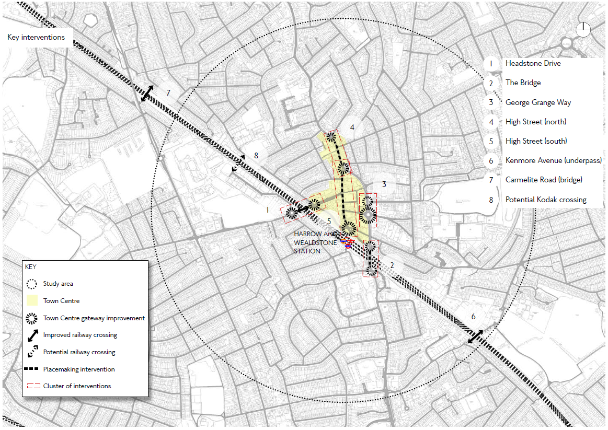
APPENDIX A – TRAVEL GATEWAYS AND CONNECTIONS

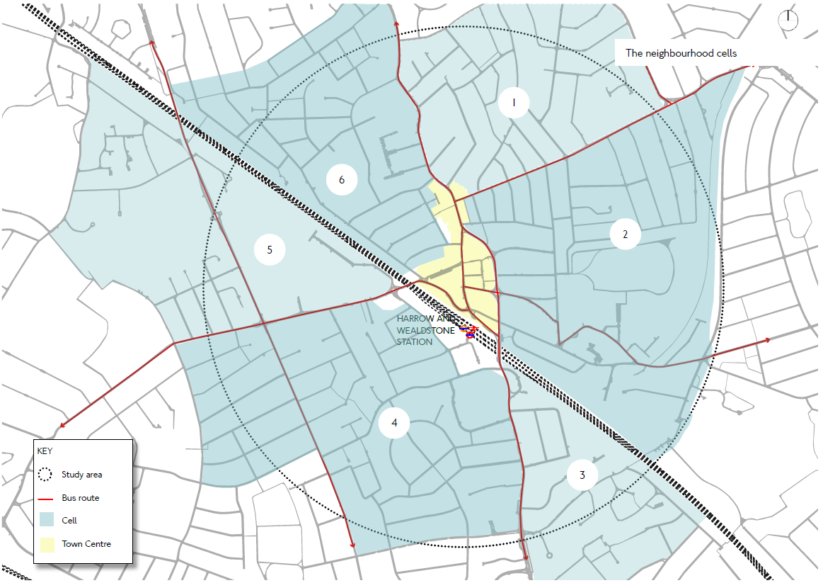
APPENDIX B – SUB-NEIGHBOURHOODS

